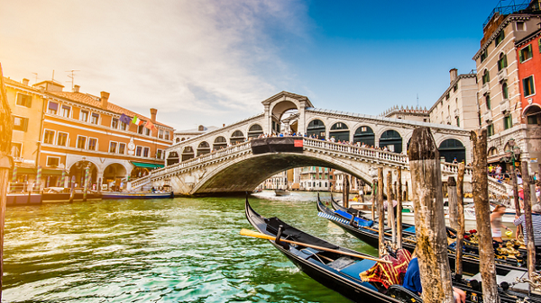**Rialto Bridge**

Rialto Bridge (Italian: Ponte di Rialto) in Venezia is one of the most famous constructions of the city. The bridge across the Great Canal (Canal Grande) only has a span of 48 m, located next to Fondaco dei Tedeschi is the commercial headquarters of the German merchants in Venice.

**History**

Around 1100 there is still no bridge across the Great Canal. According to Andrea Dandolo's Chronica per extensum descripta, a wooden bridge was built in 1246 under the governor of Renier Zen. The bridge was damaged several times due to quickly damaged construction materials or fire and it was not until 1507 that the city decided to build a brick bridge. This was followed by a decades-long debate over the finances and shape of the bridge. Although many famous architects, including Michelangelo and Andrea Palladio, participated in the competition but eventually the sketch of a lesser-span bridge by less famous architect Antonio da Ponte was chosen. The final bridge was decided to be built in 1588 and completed in 1591.